**Lab 6: Data Visualization**

**Instructions**

* Create a Quarto file called "Lab 6: Data Visualization".
* Copy the questions/prompts with the numbers/letters into the markdown file as text (i.e., in between code chunks, without any #). Use a header for each question #.
* Provide the code responses into code chunks directly beneath the questions (or beneath the text if the question requires both verbal and code answers).
* Submit both a knitted html or docx file and your .qmd file to ELMS before 11:59pm.
* *See ‘lab assignment demo’ file (.qmd) on ELMS or Jupyter for an example.* *Do not directly edit this file, instead create your own markdown file, copy the content from the demo and edit that.*

**Note:** For all questions, be sure to recreate *all* aspects, including plot titles and axis labels. The colors are simple named colors in R, but if you don’t match those exactly, that’s fine.

**Question 1**

Recreate this figure using the built-in *Seatbelts* data frame.

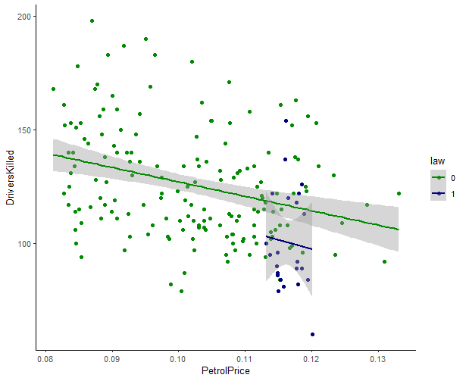

**Question 2**

Recreate this figure using the built-in *ChickWeight* data frame with the line representing the mean of the weight variable.

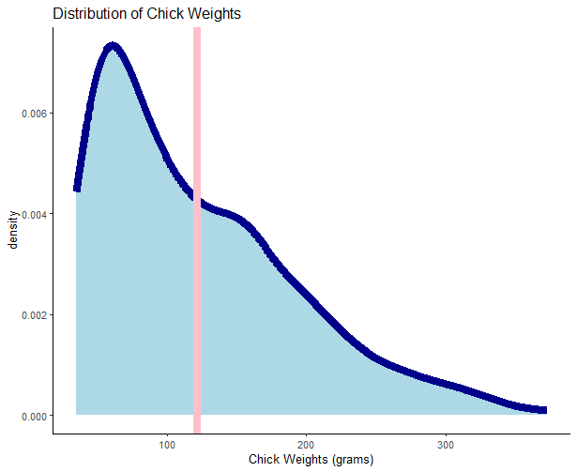

**Question 3**

Recreate this figure using the built-in *mtcars* data frame.

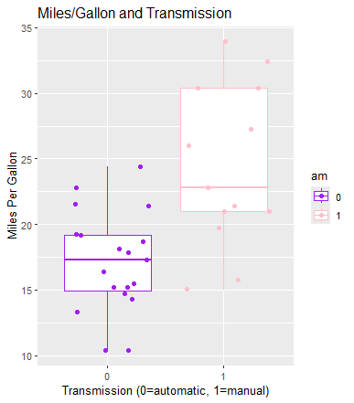

If there is missing data, you should print the column number and how many values are missing. For instance, "Column 1 has two missing value(s), Column 3 has one missing value(s)" and so on. (NOTE: There are a few approaches here. NA %in% object_name will tell you whether there is at least one missing value in an object. is.na(vector_name) will print a vector of TRUE/FALSE for whether every element of a vector is missing (i.e., NA) or not. Hint: You will need to loop through the columns one by one; consider using a paste() statement to get the output described above. Test the function on the data frame below: